Abhinav Bharadwaj **R**

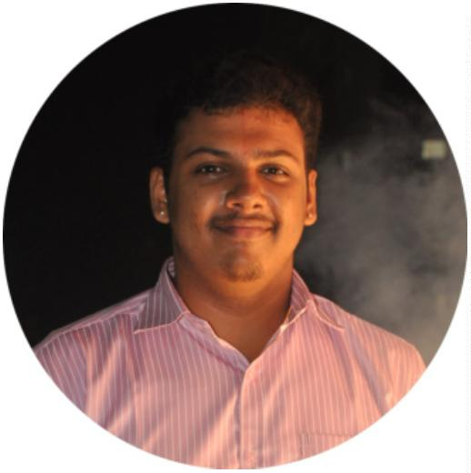

bharadwajsharma1997@gmail.com+91 9500188610

G1, No.10, G1, G.R.Flats, Jagadambal Street, Vijayalakshmi Puram, Ambattur,Chennai 600053

LinkedIn : @imabhinavbharadwaj

EDUCATION Bachelor of Engineering (B.E), Computer Science And Engineering

SMK Fomra Institute of Technology

2015 - 2019

CGPA: 6.64/10

Senior Secondary (XII), Science

G.K.Shetty Vivekananda Vidhyalaya Junior College

(CBSE board)

Year of completion: 2015

Percentage: 85.60%

Secondary (X)

G.K.Shetty Vivekananda Vidhyalaya Junior College

(CBSE board)

Year of completion: 2013

CGPA: 8.60/10

JOBS Network**ing** Engineer

Tejas Networks Limited, Bangalore

Nov 2019 - Present

my Role as a Networking Engineer at Tejas is to configure the Equipments at Consumer End, Demonstrate them about the Network Equipments and briefly explain about its functionalities. Working with Backbone Networking Equipments like Multiplexer - Demultiplexer, Routers, OSPF Mapping, ONT, OLT and OTN Equipment Configuration, Hands-on experience with GPON Technology and Intra-IT Infrastructure network elements. Beginner experience in NMS and EMS configuration. Strong hand in Server OS Installation, Migration and Maintenance.

INTERNSHIPS DotNET & Python

DLK Technologies, ChennaiJun 2018 - Jun 2018

Internship was carried out on Various Software Development Technologies andTools available to work with .NET Tools and Development Cycles as well as howthe Industry is adapting to Python Implementation.

J AVA & PHP

DLK Technologies, ChennaiMay 2018 - Jun 2018

Internship was carried out on Java Development Tools and Techniques for aSoftware and the about the process of Software Development Cycle (SDC) in theIndustry. In addition, utilization of PHP across the Web were explained.

Database Building/Management

Ayan Tech Solutions, Chennai

Jun 2017 - Jun 2017

A 2-week Intern at Ayan Tech Solutions. Learned about various kind andapplication of Database in an organization. Gained knowledge SAP Shop and

How SAP implementation is carried out by companies like Caterpillar and many more.

POSITIONS OF Resource Co-ordinator for an Institution Event. RESPONSIBILITY

Having been given the Role to co-ordinate the Resources (Technical / Non- technical) required to successfully conduct our Department Symposium "Graꢁyak19", had to manage various Requirements.

English Club Representative for Department of Computer Science andEngineering

Held the Responsibility of representing my Department at our Institution's EnglishClub at Shree Motilal Kanhaiyalal Fomra Institute of Technology, Chennai

TRAININGS Extended Reality Workshop

Cognit'18, Chennai

Aug 2018 - Aug 2018

One Day Workshop was organized in-order to give a Brief introduction toExtended Reality which Involves all real-and-virtual combined environments and human-machine interactions generated by computer technology and wearables.

Amazon Web Services Workshop

DLK Technologies, Chennai

Jun 2018 - Jun 2018

One Day Workshop on Tools and Process involved in AWS Environment conducted by DLK Career Development on 22 June 2018.

Intent 2018

Agni College Of Engineering, ThalamburMar 2018 - Mar 2018

2days of Brief Workshop conducted in collaboration with Negits with FieldExperience Personalities on Artiꢁcial Intelligence and Machine Learning, Internet Of Things, Cloud Technology and Industrial Automation.

Android Application DevelopmentCodeBind Technologies, ChennaiDec 2017 - Dec 2017

One Day Workshop on how to Develop an App for Android Devices and the Process behind siging our Application Pacakge (.apk), Publishing our App onGoogle Play Store and Working with Firebase.

Web Development In-plant TrainingCodeBind Technologies, ChennaiDec 2017 - Dec 2017

Skill Enhancement Program

Shree Motilal Kanhaiyalal Fomra Institute Of Technology, Kelambakkam

Dec 2016 - Dec 2016

Junior Diploma In Computer Hardware (JDCH)

CSC Computer Education Center, Maraimalai Nagar

May 2005 - Jun 2005

Completed a Junior Diploma in Computer Science (JDCH), a Diploma course from 04 Apr 2005 to 04 June 2005 with "A" grade.

Junior Diploma In Computer Science (JDCS)

CSC Computer Education Center, Maraimalai Nagar

[Apr 2005 - May 2005](https://github.com/imAbhinavBharadwaj/symptomanalysisanddiseaseprdiction)

[Completed a Junior Diploma in Computer Science (JDCS), a Diploma course from](https://github.com/imAbhinavBharadwaj/symptomanalysisanddiseaseprdiction) 20 Apr 2005 to 20 May 2005 with "A" grade.

PROJECTS Symptom Analysis and Disease Prognostication Using Machine Learning Over

Big Data

Jan 2019 - Mar 2019

https://github.com/imAbhinavBharadwaj/symptomanalysisanddiseaseprdiction

A Major Project work done exploring Machine Learning Algorithms andMethodologies that can be Used over the Patient Data to Prognosticate theirHealth Stats and Diseases based on their Symptoms Experienced.

SKILLS

|  |  |
| --- | --- |
| Tamil Proꢀciency  Native | English Proꢀciency  Advanced |
| Hindi Proꢀciency  Advanced | Algorithms  Intermediate |
| Enterprise Resource Planning(ERP)  Beginner | UI & UX Design  Intermediate |
| C Programming  Intermediate | C++ Programming  Intermediate |
| Java  Intermediate | C#  Beginner |
| Python  Beginner | Perl Scripting  Beginner |
| Linux  Intermediate | Windows (Administration)  Advanced |
| Windows (Maintenance)  Advanced | Android  Beginner |
| Database Management System (DBMS)  Intermediate | MySQL  Intermediate |
| HTML  Intermediate | CSS  Intermediate |
| PHP  Intermediate | JavaScript  Intermediate |
| Swing (Java)  Intermediate | Adobe Dreamweaver  Intermediate |
| Eclipse (IDE)  Intermediate | GIMP  Intermediate |
| Microsoft Office  Advanced | Microsoft Excel  Advanced |
| Microsoft Outlook  Advanced | Microsoft Access  Intermediate |
| Microsoft Visual Studio  Intermediate |  |
|  |  |

WORK SAMPLES GitHub proꢀle

https://github.com/imAbhinavBharadwaj

Other portfolio link

https://www.pinterest.com/imabhinavbharadwaj

ADDITIONAL DETAILS Interest : Administration, Data Management and Organisation, IT Operations, Technical Operations and Support, Android Development, Network Engineering, Machine Learning and Artiꢁcial Intelligence

Capabilities and Traits : Pushing towards Perfection, Observation, Tea m Co- ordination, Group Activities, Straight Forward, Being Committed to a Task,Flexible, Optimist

Hobbies : Housekeeping, Music, Reading Stuff (Paper Print / Digitals), Cooking(Occasional), Nature Watch, Fitness time